PERCEIVED “RESOURCE DEPENDENCE” AND CANADIAN PUBLIC UNIVERSITIES:

Building Fine-Tuned LLM Classifiers for Text Analysis

Sara Murphy
Western University
Computational Text Analysis
Professor: Sebastian Vallejo Vera
Due: April 17, 2026

This research extends previous research I have conducted in the context of Canadian publicly funded universities and their strategic adaptation to government policy shocks. This research is grounded in organizational theory literature about “resource dependence,” which states the level of power an organization (i.e. university) has in its relationship with an outside organization (i.e. government) is the inverse of its dependency upon that outside actor for resources to achieve its goals. My past research has focused on resource dependence in an objective sense. However, resource dependence is also argued in the literature to be a subjective concept, in which one’s perception or interpretation of their dependency has an important impact on one’s strategic behaviour. As a result, this research project – for the first time in the literature, as far as I am aware – leverages computational text analysis techniques (specifically, fine-tuned classifier models built using an LLM encoder, RoBERTa), to allow for an empirical assessment of public university perceptions of how “resource dependent” they are upon government. These fine-tuned classifier models, which currently show promising indications of accuracy, open a wide range of possibilities for future empirical papers to answer important resource dependence related research questions of a more subjective nature within the public sector.

Empirical Context: Ontario Universities Post-2019
Most Canadian universities are publicly funded, receiving a large portion of their budgets through government funding and/or regulations. Typically, provincial governments provide funding for operating budgets. This is done through funding grants that are tied to enrollment and other metrics as well as through the regulation of tuition rates. In contrast, the federal government typically provides funding through research grants and through regulation of international student immigration.

Since the 1990s, the Ontario government has shifted away from providing more operating funding per student and towards allowing universities to increase tuition rates to grow revenue (Mackenzie, 2004). By 2018, domestic tuition rates in Ontario became the highest in the country (Ontario Newsroom, 2022). In January 2019, a new Ontario provincial government, led by Premier Doug Ford, surprised universities and colleges when it announced a 10% cut to domestic tuition rates across all institutions and programs and a subsequent domestic tuition freeze with no end date given; this freeze remained in effect until Spring 2026 (Ontario Newsroom, 2022; Callan & D’Mello, 2026). In early 2024, Queen’s University, one of the oldest and most prestigious universities in Ontario, began to proclaim that they could “cease to exist” soon if the government tuition freeze was not removed (Tosello, 2024). By the Spring of 2024, approximately 40% of Ontario universities were reporting operating deficits (Rushowy, 2024). As of 2025, these operating deficits totaled $300 million, with universities warning these deficits could grow to $600 million in 2026 (Baxter, 2025). However, roughly 60% of Ontario universities within this same policy context were able to report operating surpluses and balanced budgets post-2019. What might explain this variance in reported financial performance under identical resource constraint? It would appear financial losses are less attributable to the policy shock itself and more attributable to the adaptive behaviour of the public institution in response to the policy shock.

Construct: Resource Dependence
A relevant construct within organizational theory and strategic management is resource dependence, which is rooted in the foundational work of Emerson from 1962. Emerson, a sociologist, argued power is not an absolute dimension rooted in individual traits but a relational, socially constructed dimension. Emerson (1962) proposed that power is the inverse of one’s dependency within a given relationship. Dependency, in turn, is related to how motivationally invested one is in the goals/rewards that the other provides and inversely related to the availability of other alternative means to achieve those goals/rewards outside of the relationship. In other words, as one’s alternative options to receive resources increases outside of the relationship, their dependency in the relationship decreases and their power increases.

Emerson’s work became a foundational idea in resource dependence theory (RDT), which focuses on strategies organizations can use to increase their power over resources in their external environment (i.e. mergers and acquisitions, joint ventures/partnerships, executive succession, political action and board interlocks; Pfeffer & Salancik, 1978). These RDT approaches treat resource dependence as an objective and quantifiable construct, defining an organization as dependent purely based on measuring resource flows. However, Emerson (1962) was also clear that power and dependence are very much perceived, and that future work should explore this dynamic. However, in organizational theory and strategic management, comparing perceptions of resource dependence has been left underexplored, with no text-based or content-based analysis techniques seemingly being leveraged in the literature. This presents an important opportunity for theoretical contribution.

Previous Research Findings
My previous research has focused on resource dependence as an objective construct, testing the presence and impact of the RDT strategy of executive succession and quantifying the causal impact of the 2019 policy shock on Ontario financial performance. As shown in the Appendices (Figures 1-7), a difference-in-differences design was used, comparing 20 Ontario universities to 18 control universities from British Columbia and Nova Scotia over the period of 2014-2024. Results indicate that while the 2019 Ontario policy shock is associated with a modest decline in operating surplus (approximately $21 million), the policy shock does not independently predict operating deficit. However, Ontario universities who appointed internal and/or less experienced candidates to the role of university president after 2019 exhibit significantly higher probabilities of deficit (8 times more likely). These findings demonstrate how and when senior leadership can mitigate/amplify resource dependence, but they do not explain why leadership change can have this mitigating or amplifying effect. Perhaps this is rooted in different leadership mindsets towards the institution’s resource dependence upon the government both before and after the 2019 Ontario policy shock.

New Research Questions
It is important to explore how resource dependence may operate as a subjective construct within the context of public universities under policy constraint. The following research questions would help investigate interesting, underexplored dynamics:

- How does perceived resource dependence moderate the financial performance of the 2019 Ontario policy shock on universities?
- How does perceived resource dependence change in response to the 2019 Ontario policy shock on universities?
- How does executive succession change perceived resource dependence pre and post the 2019 Ontario policy shock on universities?

Computational text analysis, combined with previously collected data on financial performance and executive succession, provides fruitful ground to answer these research questions. The focus of the remainder of this essay is to explain the process used to develop two fined-tuned classifier models using an LLM encoder in order to: a) detect the presence of perceived resource dependence language in public facing university communications and b) detect the intensity of perceived resource dependence language as being low (with more agency) versus high (with little to no agency).

DATA AND METHODS
This section outlines the data sources used for the fine-tuned classifier models, the data pre-processing conducted, the use of human versus computer annotation and the logic behind these decisions.

Data Source: Operating Budgets, Introduction Section
To tap into the latent dimension of perceived resource dependence, this research project needed to locate a language-based data source where public universities would be expected to frame their interpretations and perceptions of government regulation and resource provision. This project selected the introduction section of university operating budgets for several reasons. Firstly, these operating budgets are created several months in advance of an upcoming academic school year, presenting an opportunity to compare the language in the budget to financial results that are incurred one-year later. Additionally, the introduction section of these operating budgets typically focuses on the external market context that is impacting budget decisions, which always includes a discussion of government policy and funding dynamics. Lastly, these introduction sections - given their prominence at the beginning of the budget - set the tone for the financial and strategic decisions that follow, thus demonstrating a strong link between words that outline perceptions and actions. These introduction sections varied in length between 1-5 pages of text within the operating budget, depending on the university or the given year.

The one major limitation of this research project can be described as the gap between potential available operating budgets and the actual operating budgets used to fine-tune the classifier models. The potential available data represents the total volume of operating budgets for the treatment and control group previously used in the difference-in-differences design, representing 20 Ontario universities and 18 British Columbia/Nova Scotia universities over a 12-year period (2014 – 2025) – which equates to 456 potential operating budgets. However, due to time limitations, a much smaller subset of operating budgets solely from Ontario was drawn upon for the fine-tuning model at this stage, representing 55 budgets between 2017 and 2025 from 11 of the 20 Ontario universities. The major time limitation came from the fact that the overall corpus needed to be hand built, with human selection required to identify the relevant introduction section within each university’s operating budget for a given year and then extract text at the unit of analysis (i.e. paragraph, see below). Each university titles this introduction section differently (e.g. Setting the Context, Introduction, Executive Summary, Changing Financial Landscape) and it also can be in a slightly different area in the beginning of the operating budget. Human judgment was required to locate these sections. Manual extraction of paragraphs worked best to accurately transfer data into an excel spreadsheet-based corpus. See the Appendices (Figure 8) for a visual example of this corpus.

Unit of Analysis and Data Pre-Processing
As previously mentioned, the chosen unit of analysis was at the paragraph level within the introduction sections of the operating budgets. This was chosen for several reasons. Firstly, choosing the entire introduction section would limit total observations to the total number of documents and thus would limit validity within a sample of 38 universities. Whereas, in contrast, the average introduction contained anywhere from 5 to 45 paragraphs, greatly increasing the potential available observations from the sample. Additionally, choosing the entire introduction would limit accuracy and proper training of a fine-tuned classifier model by requiring the model to ascertain an overall determination of perceived resource dependence and perceived resource dependence intensity across an entire section of a document. Likewise, choosing the sentence level may limit accuracy as well by focusing on individual phrases and not the context that surrounds those phrases to ascertain perceived resource dependence or its intensity. As a result, the paragraph level was chosen, which contained fewer than 288 per paragraph across the sample used for the fine-tuned classifier models.

However, once again, there was a gap between potential available operating budgets and the actual operating budgets used to fine-tune the classifier models. Assuming an average of 12 paragraphs per introduction, the potential available data equates to roughly 5,500 observations. However, due to the limited sample size of 55 budgets from 11 Ontario universities, a total of 644 observations were drawn upon.

In terms of data pre-processing, no techniques were applied. All paragraphs within the “introduction section” where transferred by hand from the document into the corpus. No sentences, punctation or numbers were removed. This decision was made to prevent the advertent removal of text that would impact how the classifier would learn what represented perceived resource dependence. Punctuation and numerical figures may provide important language signals that I did not want to remove as noise and thus harm validity through.

Human Annotation versus LLM Annotation
I chose a human, hand-coded approach to classify the text in terms of its “ground truth” of perceived resource dependence and high/low perceived resource dependence intensity. This was done due to the human nuance required to understand these classifications and since the codes needed to continuously be revised in real-time to help the fine-tuned classifier learn. At the time, it was more efficient as well as valid to continue to rely upon human rather than computer-based annotators to do this work. However, LLM’s could be used to annotate a larger corpus in future iterations once the fine-tuned classifiers achieve more stability, which it appears they have achieved now.

ANALYSIS
The main computational text analysis technique applied was the use of an LLM encoder architecture (RoBERTa) to build two fine-tuned classifier models. RoBERTa was used via Google Colab code (written in python) provided by Professor Vallejo in Western’s Computational Text Analysis graduate course and via a DeepInfra API key also provided by Professor Vallejo. I used this code as a basis to apply their own dataset and to make fine-tuning adjustments to their model. See the Appendices (Table 1) for public Google Colab page links, used to conduct the rounds of analysis.

I chose to build two separate but related fine-tuned classifier models to thoroughly detect the latent dimension of perceived resource dependence. I discovered it was important to first ensure an LLM could differentiate between language that was strictly related to the budgeting process or simply describing changes in an external environment and the language that truly conveys a subjective perception of agency, opportunity or challenge related to that environment and a planned budget. As a result, the first fine-tuned classifier model was a binary model built to purely detect between 0 (no perceived resource dependence) and 1 (perceived resource dependence). See the Appendices (Figure 9a) for an example of the codebook that represented how I coded these classifications. The second fine-tuned classifier model subsequently sought to classify any perceived resource dependence paragraphs as being high versus low in terms of how constrained the public university appeared to feel and think themselves to be. This second fine-tuned classifier model was also a binary model built to purely detect between 0 (low perceived resource dependence) and 1 (high perceived resource dependence). See the Appendices (Figure 9b) for an example of the codebook that represented how I coded these classifications.

These codebooks were developed and refined multiple times by continuing to read and compare the paragraphs within the sample and review the performance of the fine-tuned classifier given the current code structure. What was most instructive for refinement was focusing on contrasting examples within the sample. One of such examples is shown in the Appendices (Figure 10). There were several pairs of universities within the sample who stood in sharp contrast to one another both in terms of financial performance and in terms of how they portrayed many different types of government policies. While I expected these contrasts to be sharpest around discussions of the 2019 policy shock, some of the strongest contrasts were about the Strategic Mandate Agreements (SMAs) with the provincial government. SMAs are signed by each university with the provincial government and outline how funding will be provided in the upcoming 2–4-year period for their school. These SMAs were in place prior to, during and after the 2019 policy shock and were beginning to change in composition prior to 2019. The government wanted SMAs to make funding less contingent on enrolment numbers and aimed more towards hitting a balance of various targets set by the government. When comparing Queen’s University to the University of Toronto, the way both schools prior to and after 2019 frame these SMAs is starkly different. As noted in the Appendices, while Queen’s portrays this shift in SMA formulation as a risky endeavour that now requires regular performance that will be unreasonable to consistently achieve, The University of Toronto portrays this shift as a welcome change they themselves advocated for because diversification a) allows the institution to leverage its strengths, b) actually stabilizes funding for the sector by basing it off more than enrollment and c) allows a university to customize the weights of the metrics it is evaluated against and makes those comparisons only off of one’s own past performance and not its peers. Contrasts like this indicate that institutions not only frame policy changes – rather than strictly report the facts – in their operating budgets, but they can also frame these changes in different ways that convey a weak or strong sense of agency as well as collaboration with the government. This indicates that the text within the introduction section of operating budgets has a strong enough signal to classify the construct of perceived resource dependence. However, it is important to note how these contrasts are rooted in human nuance that the LLM based classifier model needs to learn how to differentiate based on clearly defined codes and strong text signal throughout the sample of observations.

To help achieve this, I conducted a 4-phase approach of building the fine-tuned models, intentionally adding more data (i.e. more paragraph observations) to improve the signal in the sample text as well as revising codes. As more observations were added, universities and yearly budgets were selected that provided the greatest opportunity for contrast and the clear and consistent application of codes to enable strong learning. See the Appendices (Figure 11 and Table 2) for a summary of observations and class sample size per fine-tuning phase.

Phase 1: Perceived Resource Dependence Classifier (Model #1)
This initial sample consisted solely of operating budget paragraphs from Queen’s University and the University of Toronto, representing operating budgets from 2017 – 2025 (9 x 2 = 18 budgets). These two institutions were believed to provide a strong individual contrast in intensity as well as clear examples of perceived resource dependence versus non perceived resource dependence. This is due to their differing financial results (with University of Toronto being in surplus and Queen’s University frequently reporting operating deficit after 2019). However, at this stage, the sample size of each class in the model was small (<200 each). Stratified K-Fold sampling was used because of some imbalance in the class sizes.

Total Observations: 327
Class 0 (No) = 184
Class 1 (Yes) = 143

Phase 2: Perceived Resource Dependence Intensity Classifier (Model #2)
Phase 2 used the Class 1 observations from Phase 1 to assess their intensity. I also added observations from Carleton University and University of Windsor post-2019. These additional observations increased sample size of Class 1(high perceived resource dependence) from what it was with a sample of Queen’s and University of Toronto alone. However, this sample still suffered from a small class of low and high intensity observations (each <200) and an imbalance in the relatively smaller high intensity class. Stratified K-Fold sampling and class weighted loss was used to help account for the imbalance in class size.

Total Observations: 236
Class 0 (Low) = 154
Class 1 (High) = 82

Phase 3: Perceived Resource Dependence Intensity Classifier (Model #2) - Increased
Phase 3 expanded upon Phase 2, adding observations from many more universities (York University, Nipissing University, Lakehead University, Wilfrid Laurier University, University of Waterloo, Western University and McMaster University) post-2019. These additional observations increased sample size of Class 1(high perceived resource dependence). However, this sample still suffered from a small class of high intensity observations (<200) and an imbalance in the smaller high intensity class. Stratified K-Fold sampling and weighted sampling was used to help account for the imbalance in class size.

Total Observations: 337
Class 0 (Low) = 214
Class 1 (High) = 123

Phase 4: Perceived Resource Dependence Classifier (Model #1) - Increased
Phase 4 in turn leveraged the entire corpus from Phase 3 (including those observations that were coded as 0 for no perceived dependence but excluded from the intensity analysis) to repeat and strengthen the Phase 1 analysis of detecting perceived resource dependence from non-perceived language. These additional observations greatly increased the overall sample size for the classifier as well as balanced out the class sizes. Stratified K-Fold sampling and weighted sampling was still used like in Phase 3.

Total Observations: 644
Class 0 (No) = 307
Class 1 (Yes) = 337

RESULTS
The Appendices (Figures 12 – 19) display the performance results for both classifier models. These results were calculated using two major approaches: A) epochs = 4, folds = 5 and batches = 16 and B) epochs = 3 (Model 1) and 4 (Model 2), folds =10 and batches = 32. Ultimately performance within the model detecting perceived resource dependence and the model detecting perceived resource dependence intensity improved in accuracy as the sample size, codes and thus the 4 phases progressed. Accuracy was measured and compared in two major ways: 1) taking the average of the final fold within each epoch and 2) find the optimal epoch within each fold (based on validation loss) and averaging across folds. See Tables 3 - 6 in the Appendices for these results.

Epochs = 4, Folds = 5, Batches = 16
Based on optimal epoch within each fold approach, the fine-tuned classifier model #1 (after completing Phase 4) performed with 0.735 mean accuracy, 0.113 standard deviation in accuracy and 0.718 mean weighted class accuracy. The fine-tuned classifier model #2 (after completing Phase 3) performed with 0.795 mean accuracy, 0.039 standard deviation in accuracy and 0.795 mean weighted class accuracy.

Epochs = 3 (Model 1), 4 (Model 2), Folds = 10, Batches = 32
Based on optimal epoch within each fold approach, the fine-tuned classifier model #1 (after completing Phase 4) performed with 0.656 mean accuracy, 0.106 standard deviation in accuracy and 0.603 mean weighted class accuracy. The fine-tuned classifier model #2 (after completing Phase 3) performed with 0.741 mean accuracy, 0.0705 standard deviation in accuracy and 0.7205 mean weighted class accuracy.

DISCUSSION
Ultimately, this research project successfully developed two fine-tuned classifier models with the ability to differentiate between regular text and perceived resource dependence language with 65.6 – 71.8 % accuracy (model #1) and differentiate between low and high perceived resource dependence intensity with 74.1 – 79.5 % accuracy (model #2). These models were trained on a total of 644 observations for model #1 and 337 observations for model #2, which represent unique, un-processed paragraphs of less than 288 tokens within the introduction section of operating budgets from 11 Ontario universities across 2017-2025. The intended use of this model is to serve as an accurate tool to predict how a given Canadian university within a given year perceived how dependent they were upon the government for resources to support its operations. In doing so, this model provides empirical support of resource dependence operating as a subjective rather a purely objective construct. This presents opportunity for various kinds of impactful research into the variation of perceptions and the strategic impact of those variations in perceptions within the public sector.

Future Directions
This fine-tuned model could and will benefit from an increased sample of observations across the Ontario university sector, which can easily be done with available operating budgets with the only limitation being time that was not available for the completion of this research project. However, there are further future directions through which this analysis can be extended. Several unique empirical papers can now be written using these fine-tuned classifier models as a conduit to answer the new research questions outlined earlier this paper: these models can be used to assess whether perceived resource dependence was a moderator that amplified or mitigated the financial impact of the 2019 policy shock; how perceived resource dependence changed in prevalence and intensity in the aftermath of the 2019 policy shock; and how executive succession (background and frequency of change) at the university president and provost level impacts the prevalence and intensity of perceived resource pre and post the 2019 policy shock. Additionally, a future fine-tuned classifier model could be designed that classifies perceived resource dependence intensity as an ordinal variable, on a scale from 1-5 or as low, medium and high. This more precise classification may provide more nuanced and practical implications for the impact of variation in perceived dependence. Lastly, this model can also be extended to emerging regions in Canada, such as Nova Scotia, and in other countries, as the United Kingdom or Australia, where other public universities are reporting large operating deficits and are experiencing strife with their government. These fine-tuned models pay help test the presence of policy contagion, demonstrating how dependence as a mindset catches on across a sector over time as a learned behaviour from one’s peers.

References

Baxter, David. (2025, January 18). International Student Cap Sees Universities Facing “across the Board” Cuts. Global News. globalnews.ca/news/10966102/international-student-cap-university-impact/.
Emerson, R. 1962. “Power dependence relations.” American Sociological Review 27: 31-40.
Mackenzie, Hugh. “Funding Postsecondary Education in Ontario: Beyond the Path of Least Resistance.” Ontario Confederation of University Faculty Associations, 2004.
Ontario Newsroom. (2022, March 23). Ontario Extends Freeze on College and University Tuition. Ontario Newsroom. news.ontario.ca/en/release/1001830/ontario-extends-freeze-on-college-and-university-tuition.
Pfeffer, Jeffrey, and Gerald R. Salancik. 1978. The External Control of Organizations: A Resource Dependence Perspective. Stanford University Press, 2003.
Rushowy, K. (2024, January 9). Almost half of Ontario universities are running deficits, putting student services at risk, council says. Toronto Star. https://www.thestar.com/politics/provincial/almost-half-of-ontario-universities-are-running-deficits-putting-student-services-at-risk-council-says/article_639ebedc-af31-11ee-bdce-47e37d4e1808.html.
Tosello, S. (2024, January 9). “Queen’s could cease to exist if we don’t deal with this issue:” faculty and staff remain skeptical. The Queen’s Journal. https://www.queensjournal.ca/queens-university-faces-imminent-closure-if-cuts-not-made-faculty-and-staff-remain-skeptical/

Appendices

FIGURE 1

Policy Impact on Operating Funds
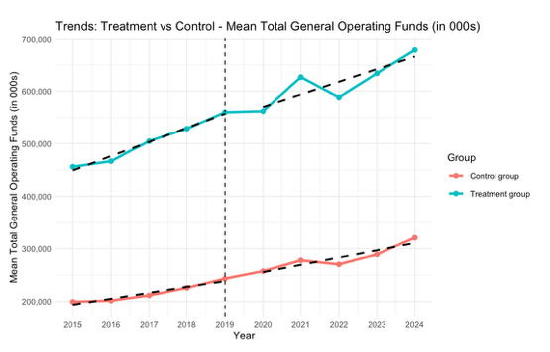

FIGURE 2

Policy Impact on Operating Funds less Operating Expenses

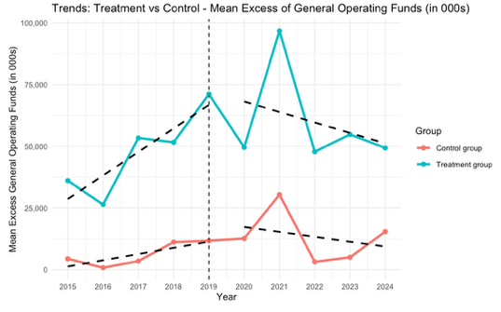

FIGURE 3

Binary Logit Regression Output – Probability of Operating Deficit (No Moderators)

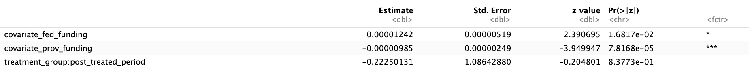

FIGURE 4

Binary Logit Regression Output – Probability of Operating Deficit (President External Hire)

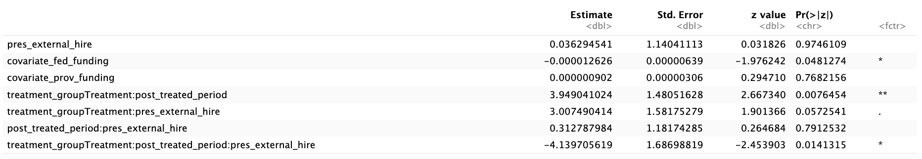

FIGURE 5

Raw Means of Probability of Operating Deficit by Treatment Group per Period

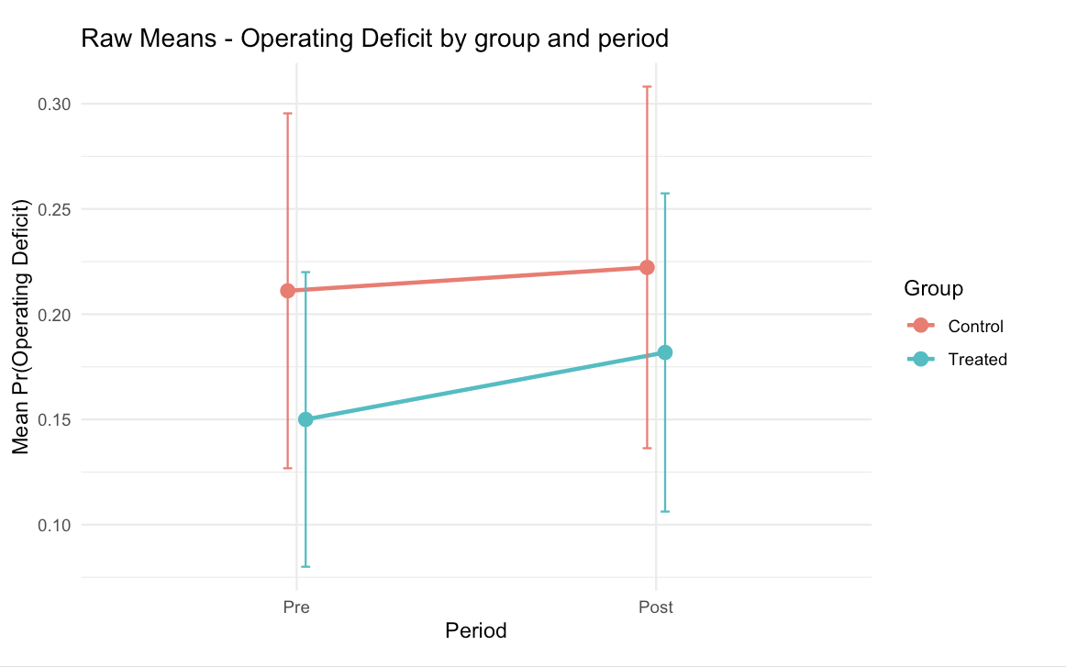

FIGURE 6

Moderating Impact of President Experience on Probability of Total Deficit

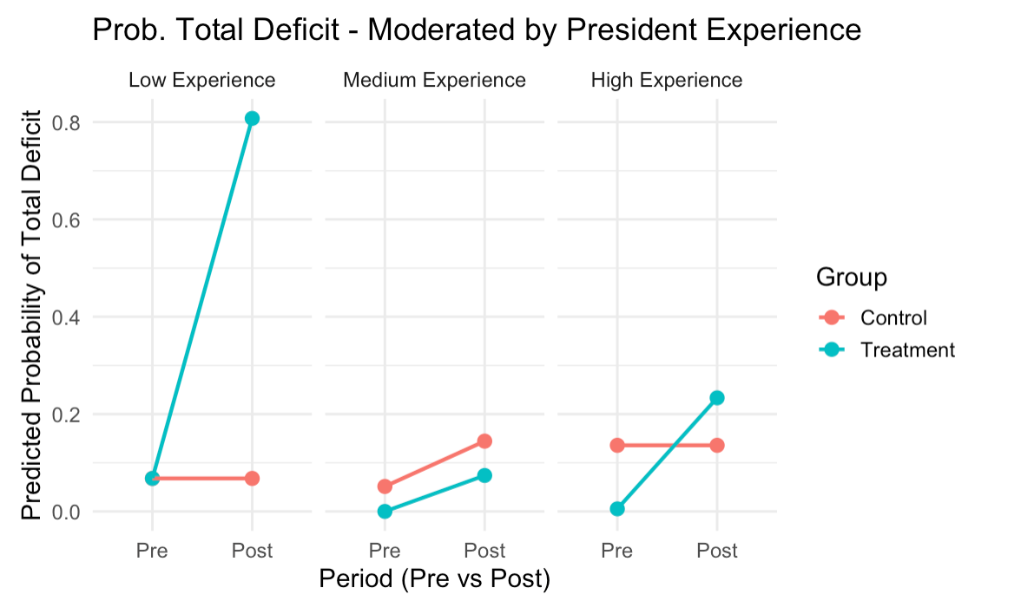

FIGURE 7

Moderating Impact of Presidential External Hire on Probability of Operating Deficit

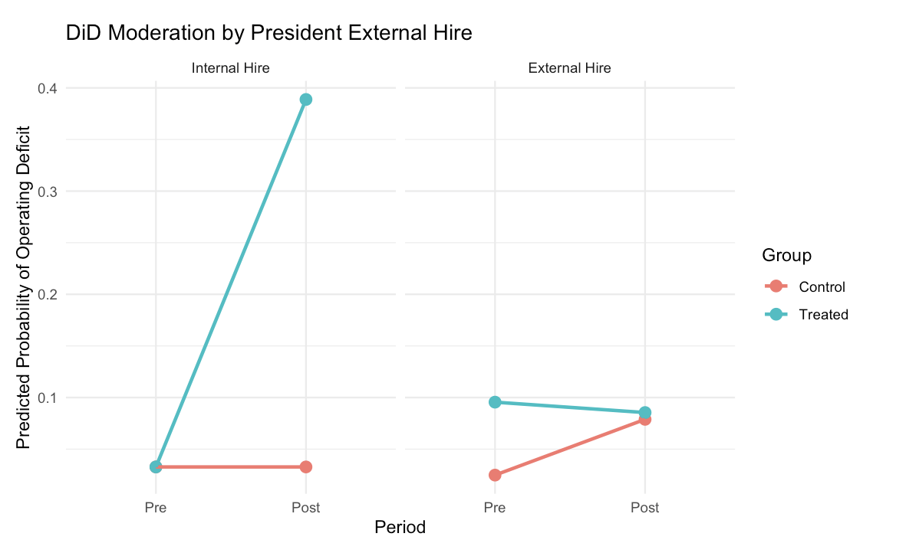

FIGURE 8

Text Analysis Corpus - Excel File (Example)

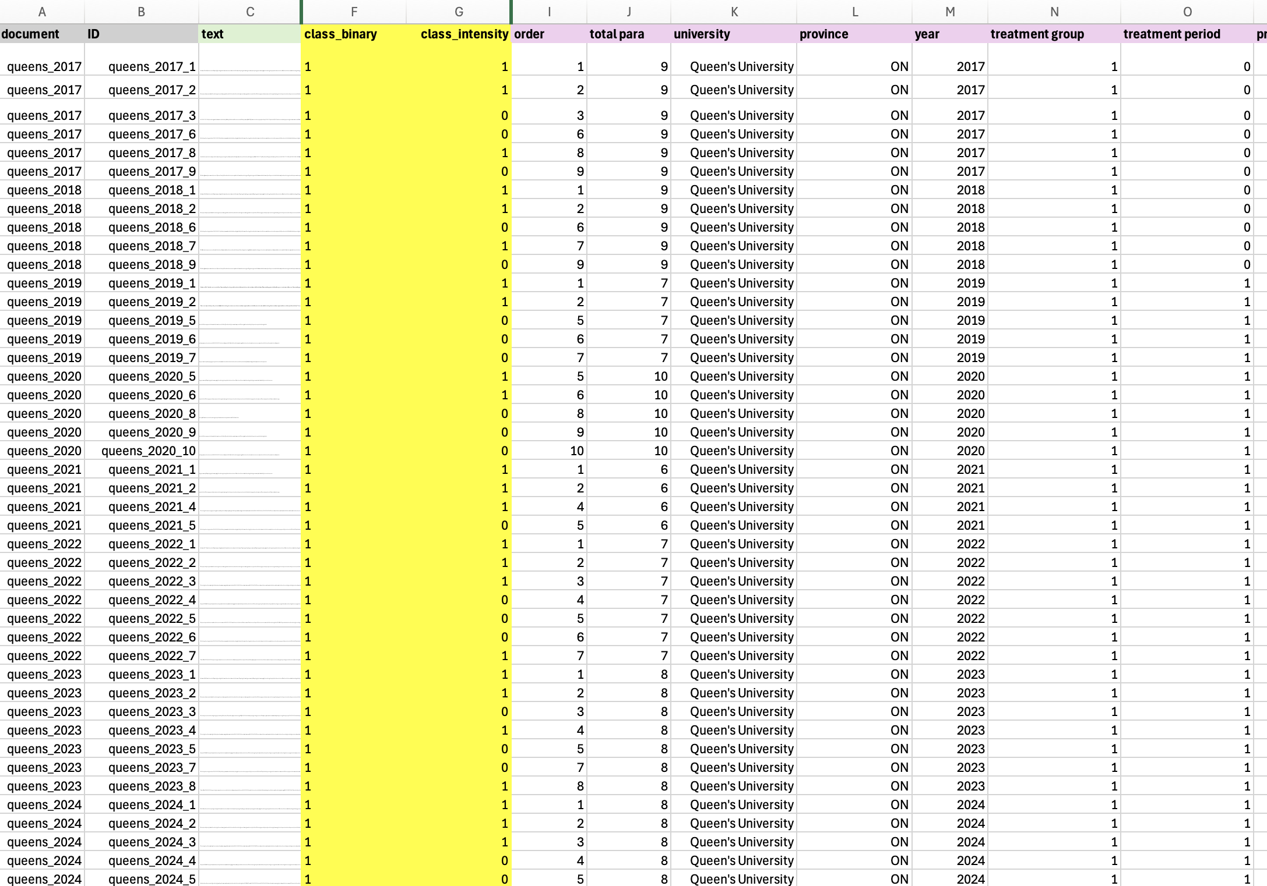

FIGURE 9

Text Analysis Codebook (Example)

Fine-Tuned Classifier Model #1

Class_Binary
    - 0 = No Perceived Resource Dependence
    - 1 = Perceived Resource Dependence

Label 0 = ANY paragraph that describes policy, funding, or risk WITHOUT evaluative language about constraint or opportunity
- Key Words and Phrases:
  - References to the global economy , Covid-19 pandemic
  - References to budgeting process, descriptive budget information only
  - general references to policies or strategic mandate agreements without any adjectives or descriptive words implying dependence

Label 1 = ANY paragraph that frames or interprets government policy or funding with some degree of agency, opportunity or portrayal as a challenge/constraint (See Fine-Tuned Classifier Model #2 codes)
Fine-Tuned Classifier Model #2

Class_Intensity
    - 0 = Low Perceived Resource Dependence
    - 1 = High Perceived Resource Dependence

Label 0 = ANY paragraph that describes government policy or funding in terms of one of either agency (we can, we will), opportunity or alternative revenue sources

- Key word/phrase indicators (low perceived resource dependence)
  - Policy is a welcomed change
  - Need to diversify revenue
  - Alternative revenue generation
  - Providing some flexibility
  - Committed to balanced budgets
  - Flexibility in the form of a contingency fund
  - Push for advocacy

Label 1 = ANY paragraph that explicitly describes government policy or funding in terms of constraint, with no mention of agency or opportunity or alternative revenue sources

- Key word/phrase indicators (high resource dependence language)
  - being in a vulnerable position
  - provincial grant revenue, although presenting with some certainty, is still financially limiting for the university
  - limited financial flexibility
  - the tuition framework continues to restrict flexibility for the university
  - restricted flexibility due to domestic tuition freeze
  - limited revenue growth opportunities

FIGURE 10

Codebook Contrast Example (Low versus High Perceived Resource Dependence):
Discussion in Operating Budgets of SMAs with Ontario Government

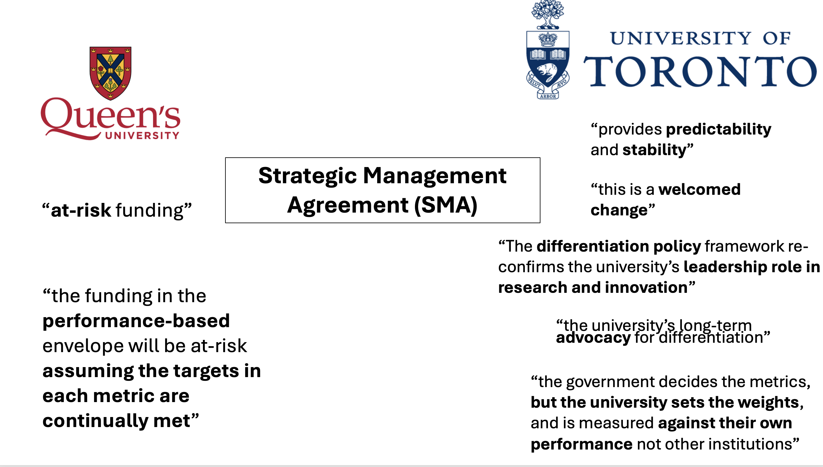

FIGURE 11

Fine-Tuning Phases: Process Flow

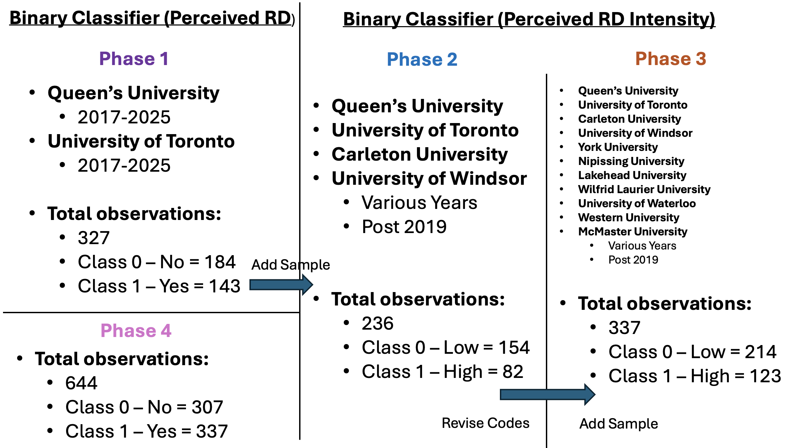
FIGURE 12

Phase 1: Fine-Tuned Model Performance
Epochs = 4, Folds = 5, Batch Size = 16, using V14.xlsx of Corpus

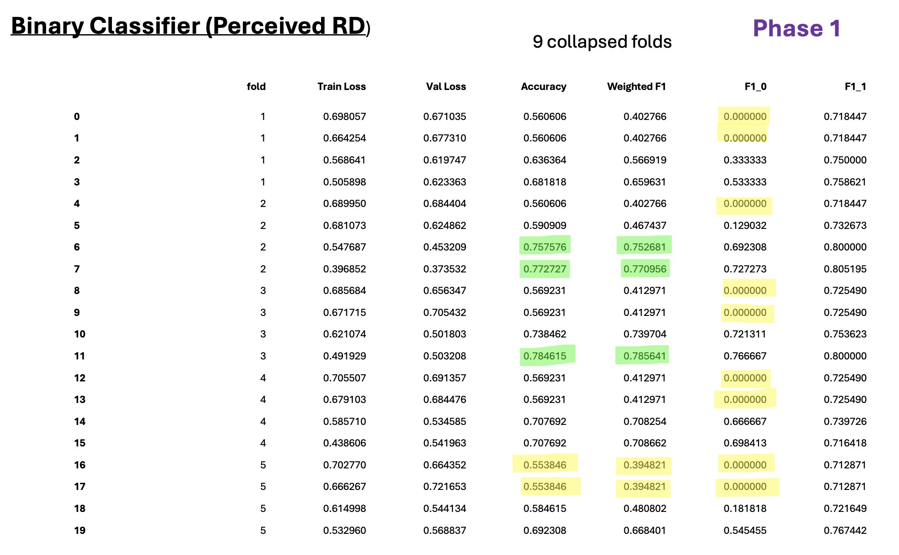

FIGURE 13

Phase 1: Fine-Tuned Model Performance
Epochs = 3, Folds = 10, Batch Size = 32, using V14.xlsx of Corpus

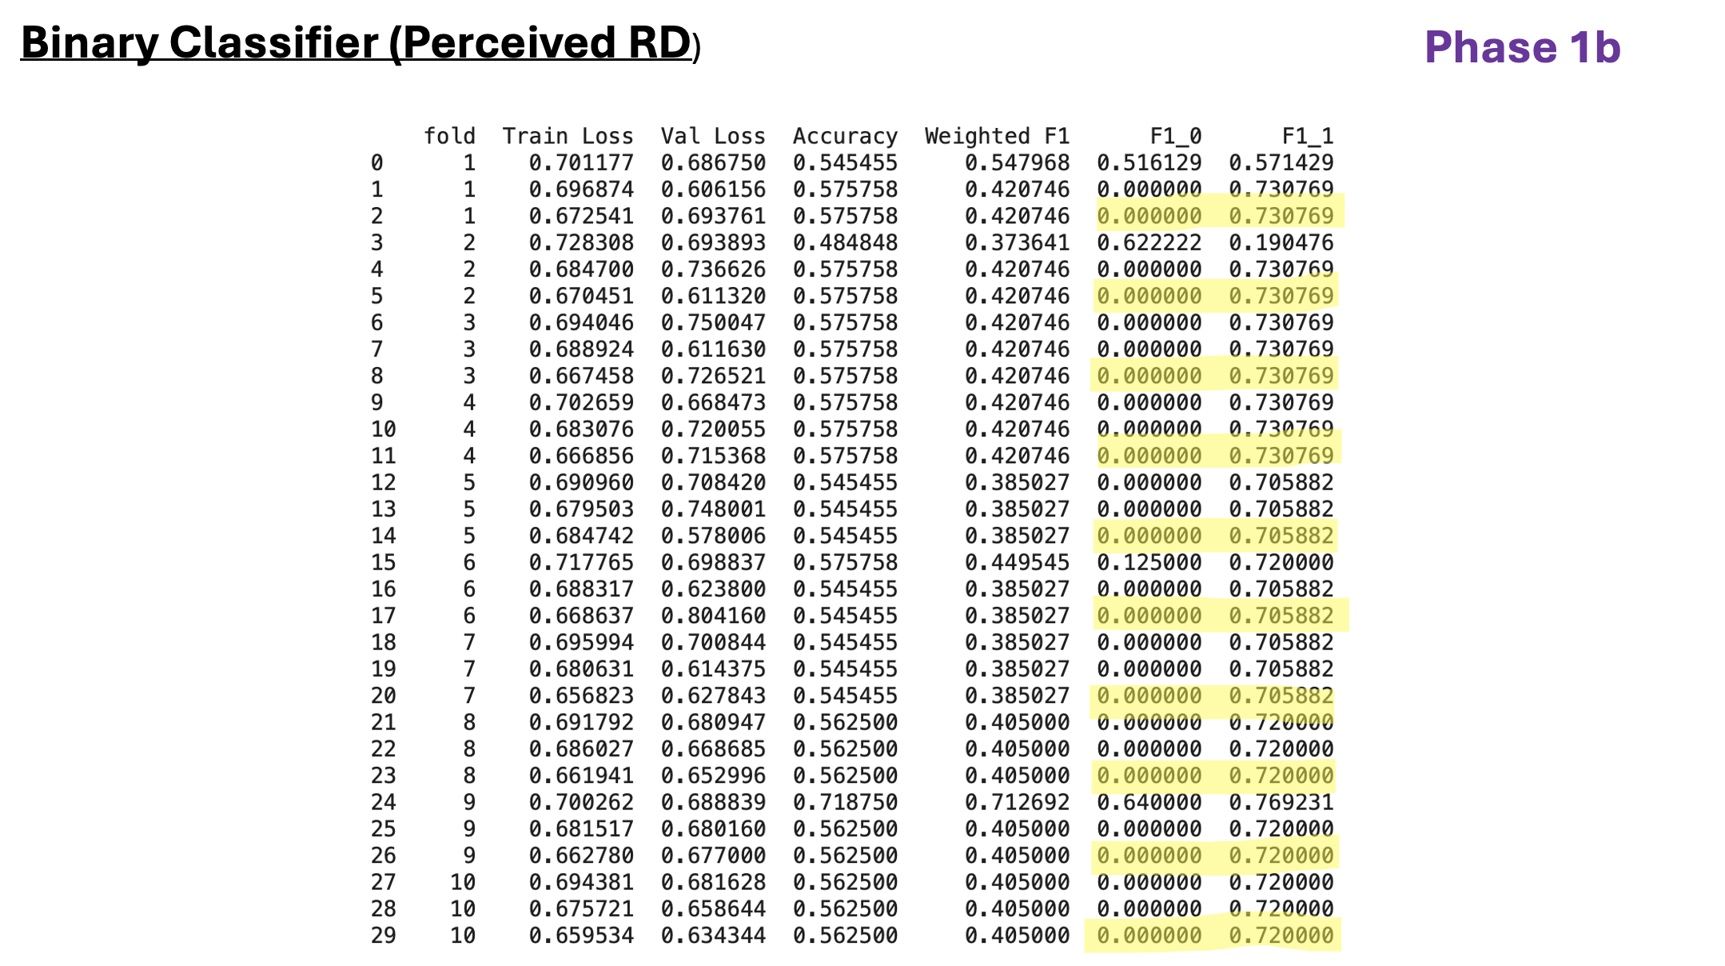

FIGURE 14

Phase 2: Fine-Tuned Model Performance
Epochs = 4, Folds = 5, Batch Size = 16, using V18.xlsx of Corpus

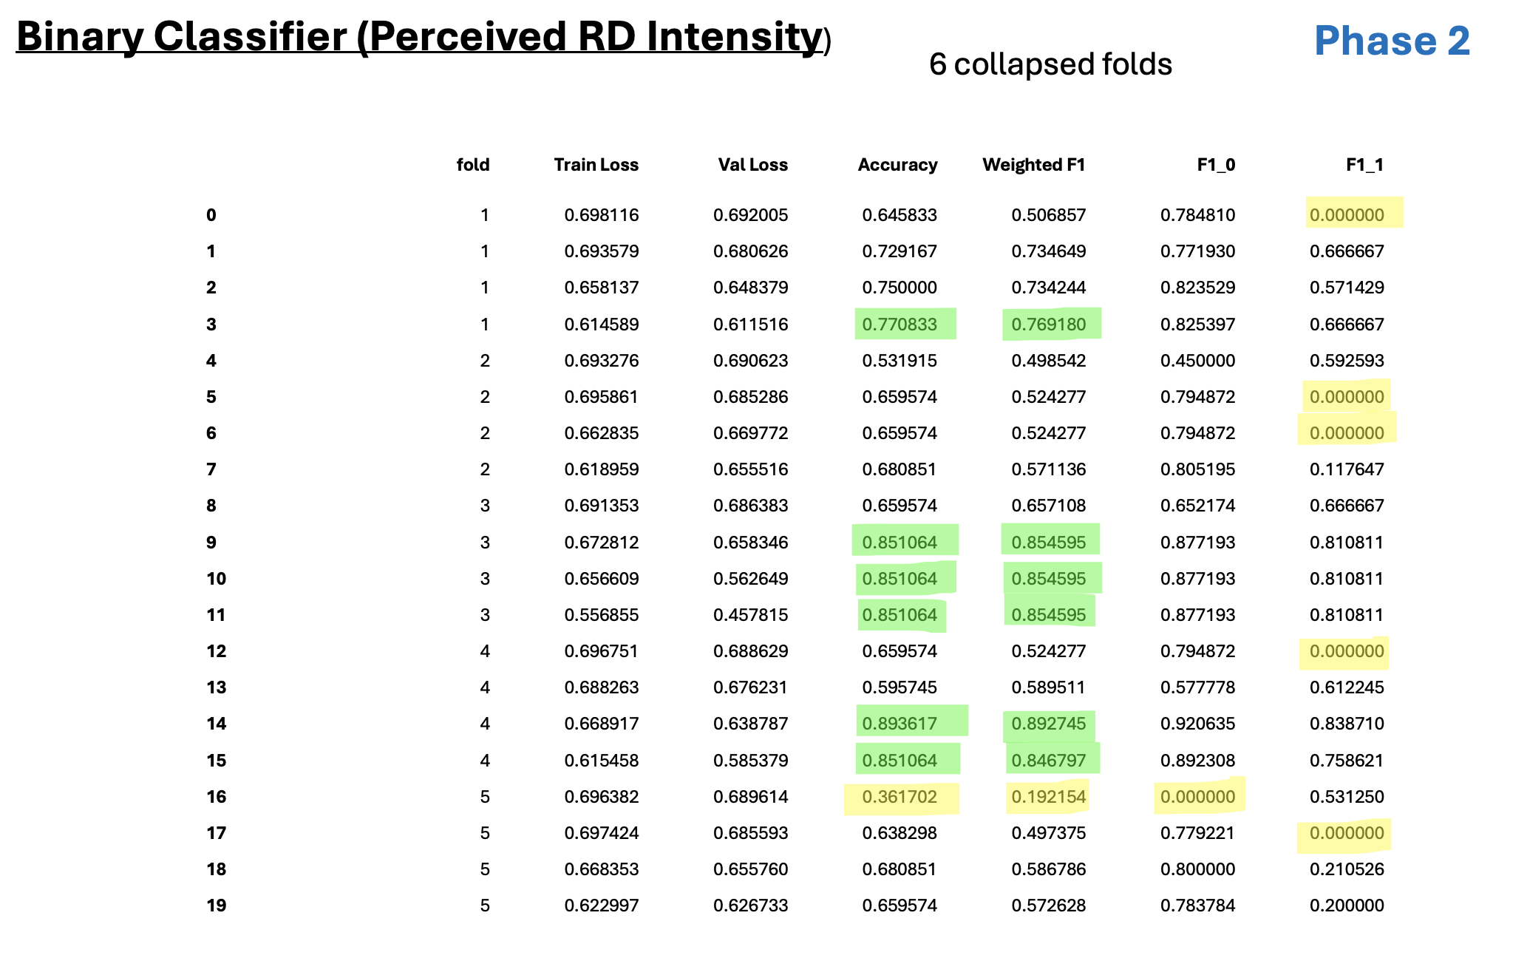

FIGURE 15

Phase 2: Fine-Tuned Model Performance
Epochs = 4, Folds = 10, Batch Size = 32, using V18.xlsx of Corpus

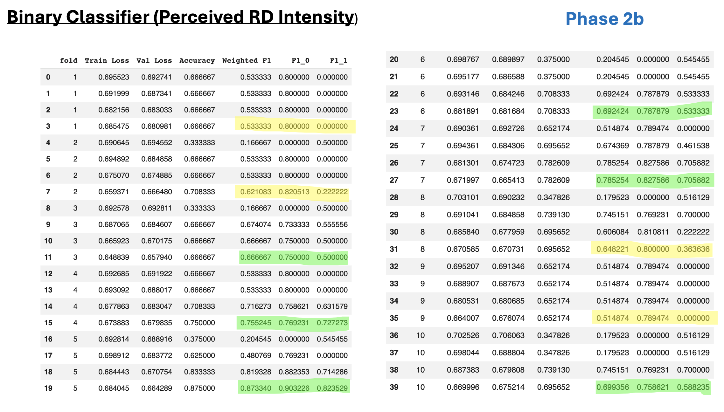
FIGURE 16

Phase 3: Fine-Tuned Model Performance
Epochs = 4, Folds = 5, Batch Size = 16, using V23.xlsx of Corpus

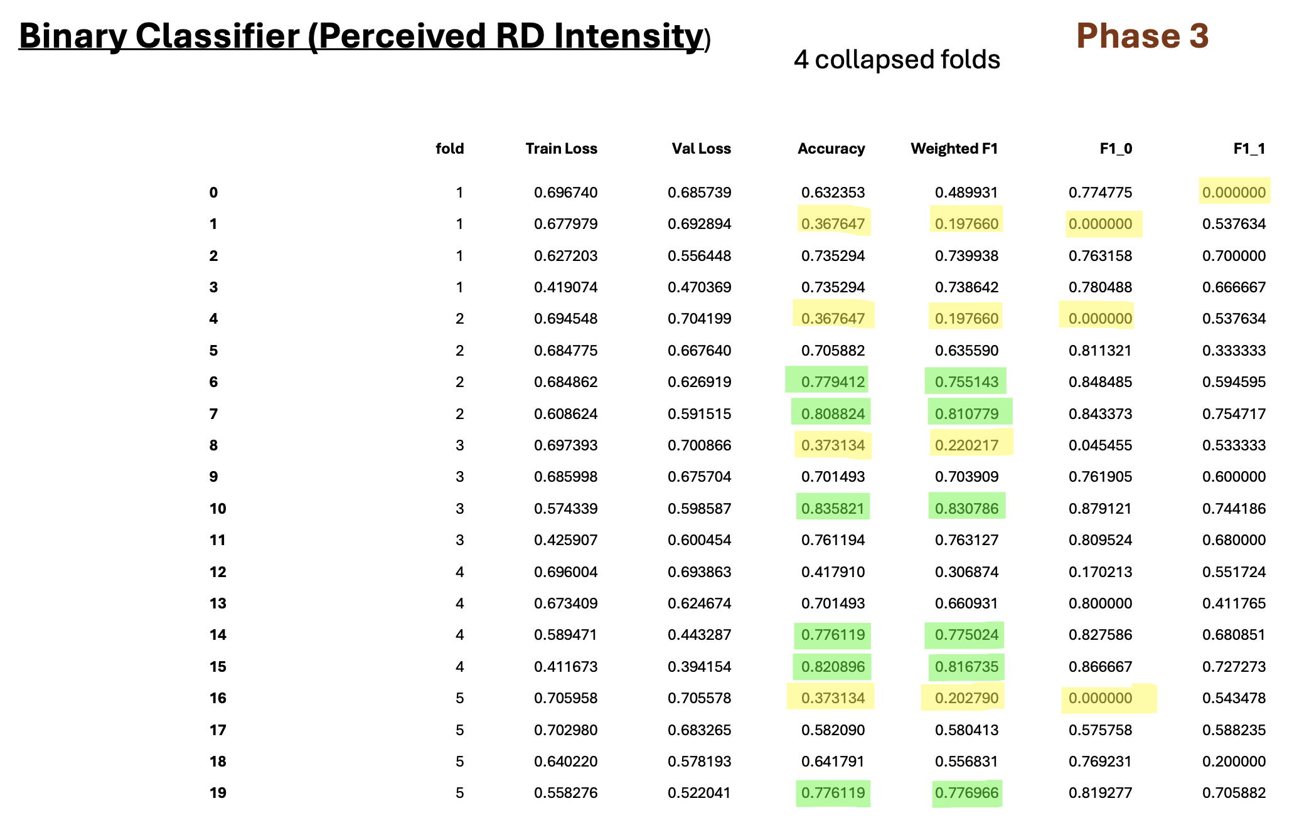

FIGURE 17

Phase 3: Fine-Tuned Model Performance
Epochs = 4, Folds = 10, Batch Size = 32, using V23.xlsx of Corpus

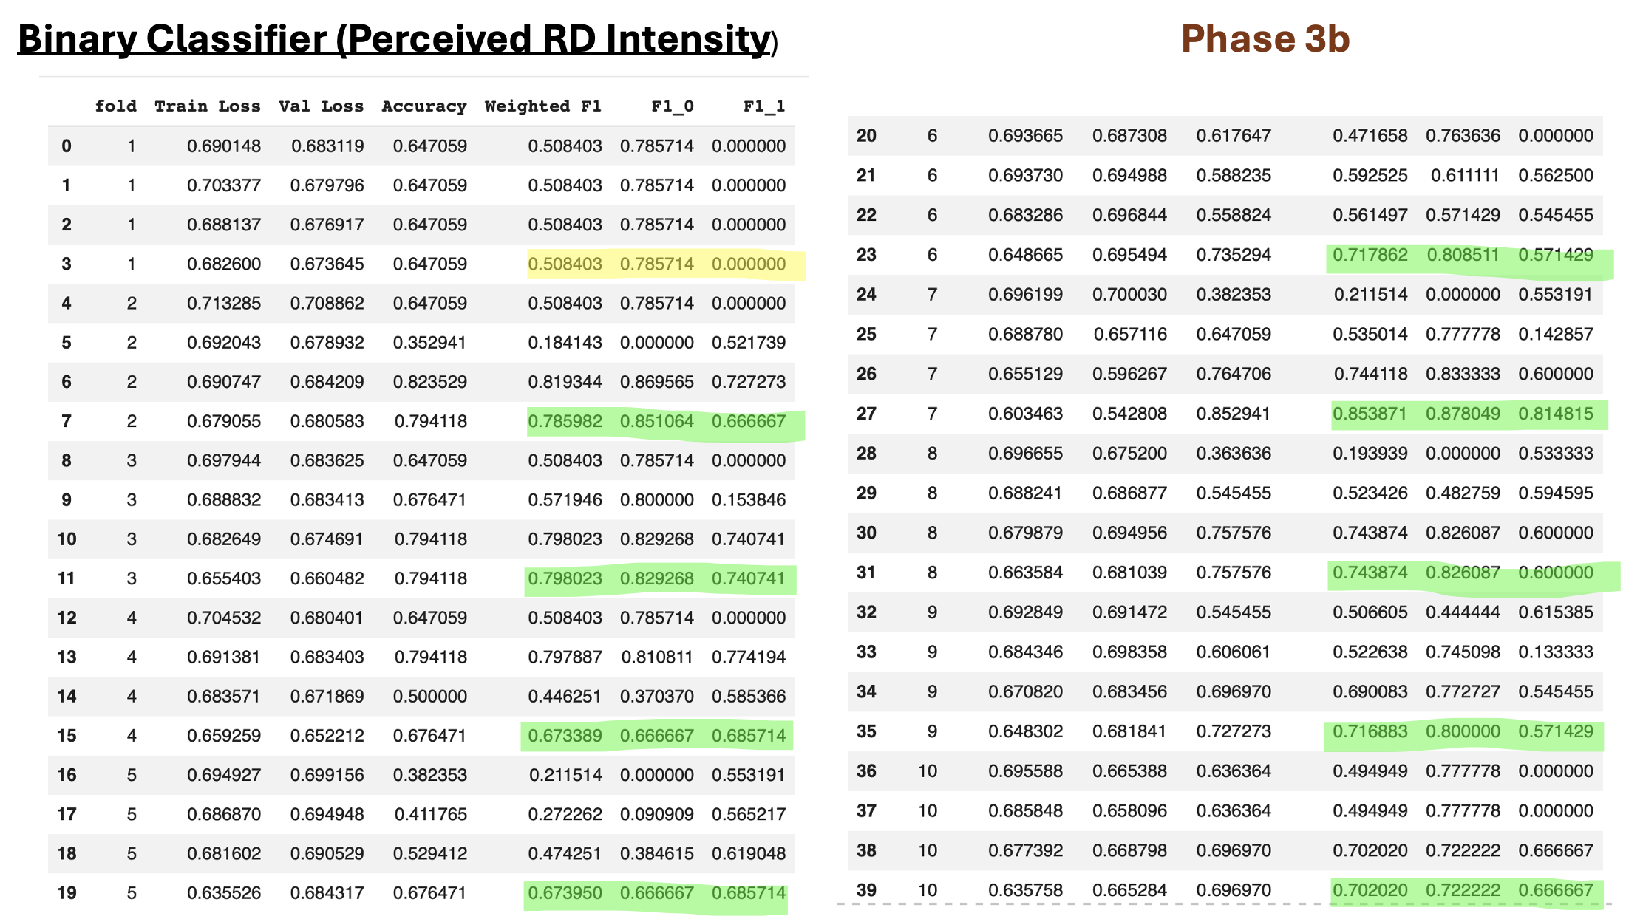
FIGURE 18

Phase 4: Fine-Tuned Model Performance
Epochs = 4, Folds = 5, Batch Size = 16, using V24.xlsx of Corpus

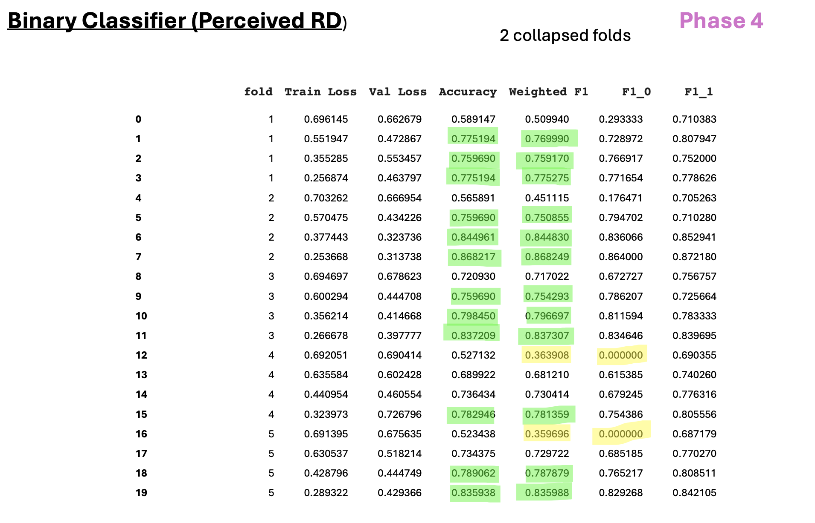

FIGURE 19

Phase 4: Fine-Tuned Model Performance
Epochs = 3, Folds = 10, Batch Size = 32, using V24.xlsx of Corpus

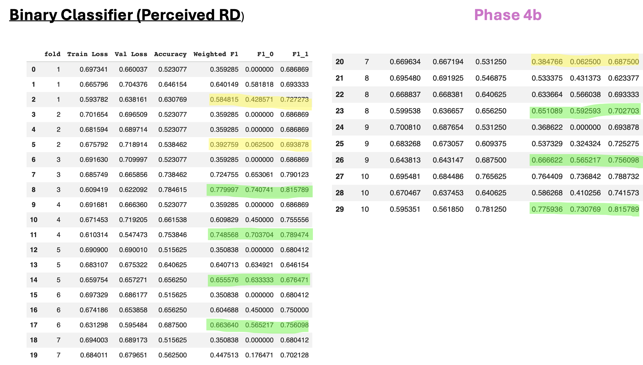
TABLE 1

Google Colab Links (Fine-Tuning with RoBERTA in Python)

FINE-TUNING PHASE | GOOGLE COLAB LINK (A) | GOOGLE COLAB LINK (B)
Phase 1- Model #1 | https://colab.research.google.com/drive/1ne8x5RwFtfyBC0FiBR7FTyK9Cht0pf6b?usp=sharing  Epochs = 4, Folds = 5, Batch Size = 16 | https://colab.research.google.com/drive/1DCJ9hH_0fnHnp3BK3-1SGirTbLpUy3Lc?usp=sharing  Epochs = 3, Folds = 10, Batch Size = 32
Phase 2 – Model #2 | https://colab.research.google.com/drive/1F0GKUYFUddvNyW7CvoQ4v9SZyGngC66Y?usp=sharing  Epochs = 4, Folds = 5, Batch Size = 16 | https://colab.research.google.com/drive/1ZLPWiWnVqOs6qh85p34BP0QQ1AbC1vvm?usp=sharing  Epochs = 4, Folds = 10, Batch Size = 32
Phase 3 – Model #2 | https://colab.research.google.com/drive/1wSY9O0TM6ihYmrEVQsAlQZjkBuFvwvEr?usp=sharing  Epochs = 4, Folds = 5, Batch Size = 16 | https://colab.research.google.com/drive/15O3brOUET6hGXI3q8ToqIkKaNpi4aTdS?usp=sharing  Epochs = 4, Folds = 10, Batch Size = 32
Phase 4 – Model #1 | https://colab.research.google.com/drive/10LrJvlT0cmnDutLtlVwm6vEZ2Y7NFF0R?usp=sharing  Epochs = 4, Folds = 5, Batch Size = 16 | https://colab.research.google.com/drive/1_lk_cvCMehdLEemOvasTSZy2qSX02Pfg?usp=sharing  Epochs = 3, Folds = 10, Batch Size = 32

TABLE 2

Summary of Observations and Class Sizes (Fine-Tuning Phases)

PHASE | MODEL | Total Obs | Class 0 | Class 1
1 | 1 | 327 | 184 | 143
2 | 2 | 236 | 154 | 82
3 | 2 | 337 | 214 | 123
4 | 1 | 604 | 307 | 337

TABLE 3

Fine-Tuned Model Performance: Epochs = 4, Folds = 5, Batches = 16
Average Performance of Final Fold Across Epochs

PHASE | Mean ACC | SD ACC | Mean Weighted F1
1 | 0.7278 | 0.0475 | 0.7024
2 | 0.6648 | 0.1866 | 0.5920
3 | 0.7805 | 0.0336 | 0.7812
4 | 0.8199 | 0.0373 | 0.8196

TABLE 4

Fine-Tuned Model Performance: Epochs = 3 (Phase 1 & 4), 4 (Phase 2 & 3), Folds = 10, Batches = 32
Average Performance of Final Fold Across Epochs

PHASE | Mean ACC | SD ACC | Mean Weighted F1
1 | 0.5612 | 0.0152 | 0.4036
2 | 0.7153 | 0.0717 | 0.6705
3 | 0.7182 | 0.1013 | 0.6943
4 | 0.671 | 0.089 | 0.630

TABLE 5

Fine-Tuned Model Performance: Epochs = 4, Folds = 5, Batches = 16
Best Performing Epoch within Each Fold, Average Across All Folds

PHASE | Mean ACC | SD ACC | Mean Weighted F1
1 | 0.688 | 0.077 | 0.653
2 | 0.759 | 0.073 | 0.726
3 | 0.795 | 0.0390 | 0.7948
4 | 0.735 | 0.113 | 0.718

TABLE 6

Fine-Tuned Model Performance: Epochs = 3 (Phase 1 & 4), 4 (Phase 2 & 3), Folds = 10, Batches = 32
Best Performing Epoch within Each Fold, Average Across All Folds

PHASE | Mean ACC | SD ACC | Mean Weighted F1
1 | 0.5621 | 0.0126 | 0.4053
2 | 0.7392 | 0.0766 | 0.7103
3 | 0.7410 | 0.0705 | 0.7205
4 | 0.656 | 0.106 | 0.603

